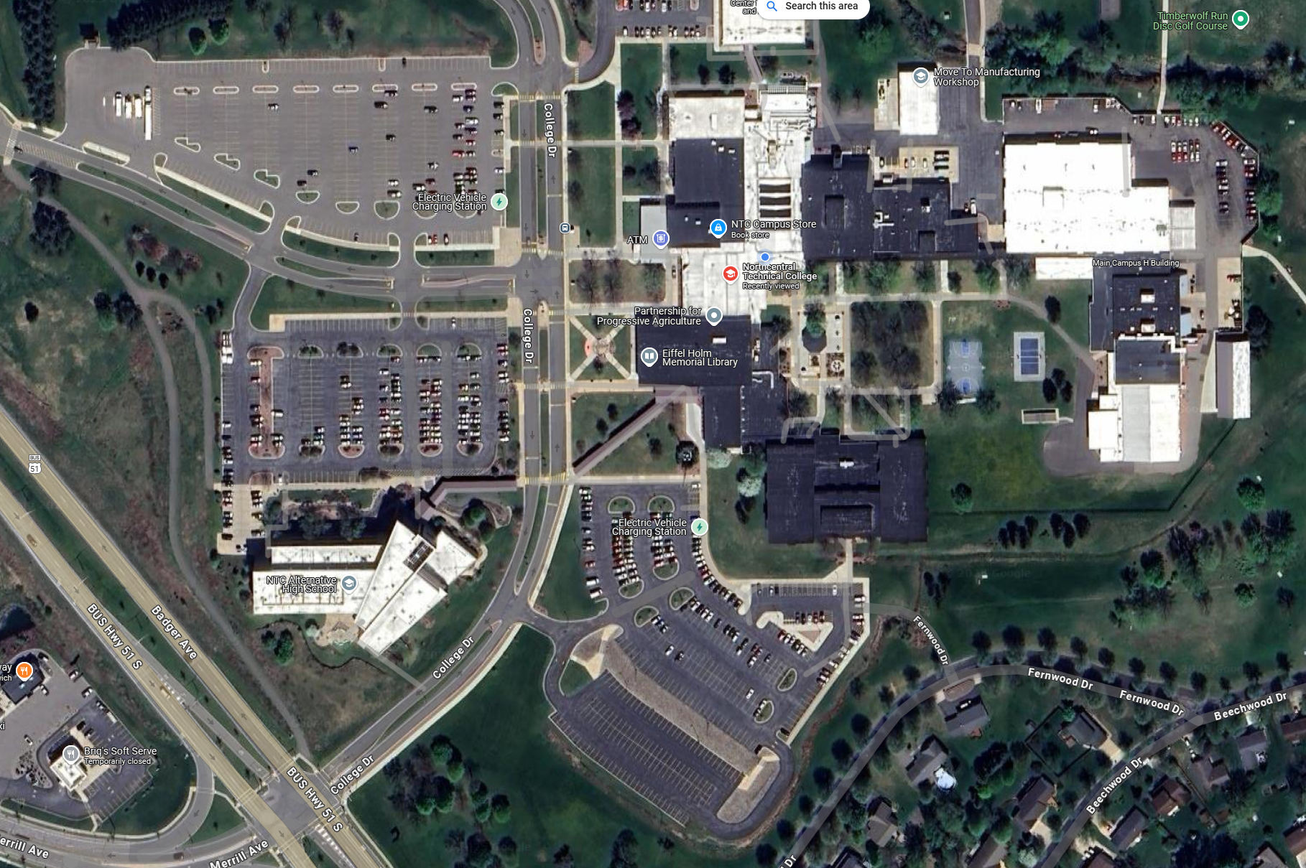
Competitions are primarily held here
Parking Available Here
Center for Health Sciences (CHS) – Opening and Closing Ceremonies

